**Submission for task 7.1 – COS30017**

**Duncan Mackay (101120310)**

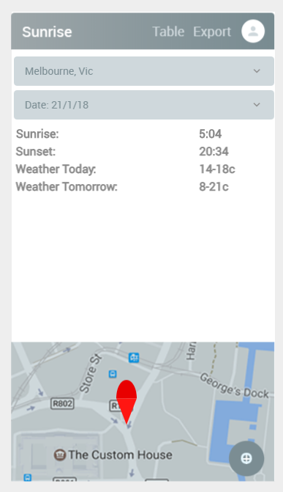Screen-Main

Main screen where the location can either be pick from the drop down or selected with the pin location on the map bellow.

The specific date can also be selected through the second drop down and users location can be collected from the gps by pressing the button in the bottom right of the map.

This was made so that a user could quickly get a days’ worth of information without going through any menus

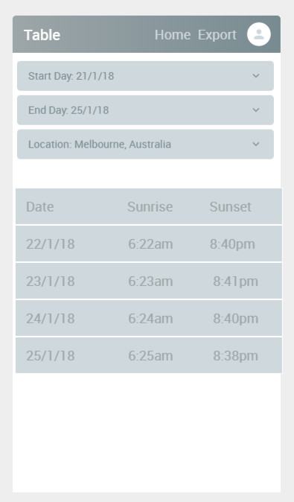Screen-TableGeneration

his is the table screen where a start and stop date can be selected as well as a location. This will generate a table the shows the sunrise and sunset times for each day for the location selected

This was added so that users who wanted to plan more time had a more complex and extended feature set on a separate page

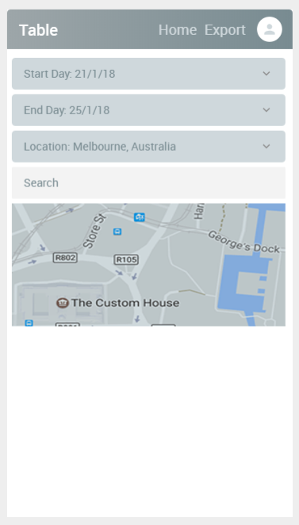Screen-TableGeneration-LocationSelection

This is a section of the Table where the location has been selected. The user can either enter the search term or use the map in order to select a location to calculate the sunrise and sunset.

Location was implemented like this so that screen space could be maintained and data could easily be followed

On all of these pages there is always the export button which allows the user to send the generated data to an external application in a text for. Therefore it can be sent through facebook, messenger, text or any other application which takes a message input in text form.

For the predetermined scenarios.

1. On the main page they can select the time and date from the relevant drop downs to generate the required information.
2. For this user they want to select table on the main page and then enter the start, end and location into the relevant fields. This will then generate them a table and they can click the export button in the top right to send to an external app.
3. This is the same procedure as case A but the location field is also changed so that the user can specifically see where they are looking for
4. On the main page this user will click the location button in the bottom right which will import their current location if the app didn’t automatically when starting. Then they can click the export button and send the data to the relevant app.